# Problem 01

## Code

clc

clear all

format short

data=[28.65 26.55 26.65 27.65 27.35 28.35 26.95 28.65 29.65 27.85 27.05 28.25 28.85 26.75 27.65 28.45 28.65 28.45 31.65 26.35 27.75 29.25 27.65 28.65 27.65 28.45 27.65 27.15];

mean_=mean(data)

median_=median(data)

mode_=mode(data)

range_=range(data)

std_=std(data)

var_=var(data)

% CV=std/mean

CV=getCV(data)

range=26:.5:32;

hist_=[];

for i=1:length(range)-1

hist_= [hist_ length(data(data>=range(i)& data<=range(i+1)))];

hold on

end

bar([26+.125:.5:32-.125],hist_)

xlabel('data')

ylabel('count')

title('histogram')

## Output

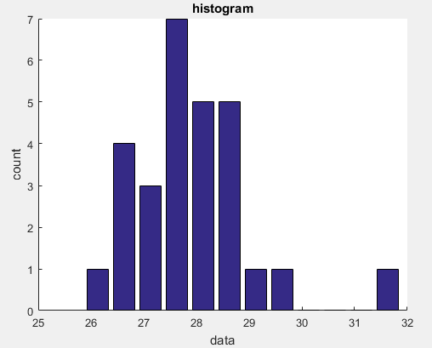

# Problem 02

## Code

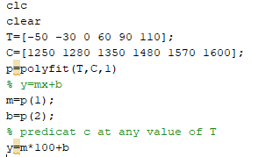

## Output

